**Project Design Phase-II**

**Data Flow Diagram & User Stories**

|  |  |
| --- | --- |
| Date | 03 October 2022 |
| Team ID | PNT2022TMID37952 |
| Project Name | IoT Based Safety Gadget for Child Safety Monitoring and Notification |
| Team batch no: | B7-1A3 |

**User Stories**

| **User Type** | **Functional Requirement (Epic)** | **User Story Number** | **User Story / Task** | **Acceptance criteria** | **Priority** | **Release** |
| --- | --- | --- | --- | --- | --- | --- |
| Customer (Mobile user) | Registration | USN-1 | As a user, I can register for the application by entering my email, password, and confirming my password. | I can access my account / dashboard | High | Sprint-1 |
|  |  | USN-2 | As a user, I will receive confirmation email once I have registered for the application | I can receive confirmation email & click confirm | High | Sprint-1 |
|  |  | USN-3 | As a user, I can register for the application through Facebook | I can register & access the dashboard with Facebook Login | Low | Sprint-2 |
|  |  | USN-4 | As a user, I can register for the application through Gmail |  | Medium | Sprint-1 |
|  | Login | USN-5 | As a user, I can log into the application by entering email & password |  | High | Sprint-1 |
| Customer Care Executive | Login |  | Once I get to operate the device, I work with it and get to know about the device and use it. Also, errors will be checked, if any it will be rectified and monitor the operation and check the authentication | Login with the provided user credentials. | Medium | Sprint-3 |
| Administrator | Login |  | Maintaining and making sure the database containing the locations are secure and accurate and updated constant. | I can login only with my provided credentials | High | Sprint-3 |

DATA FLOW:

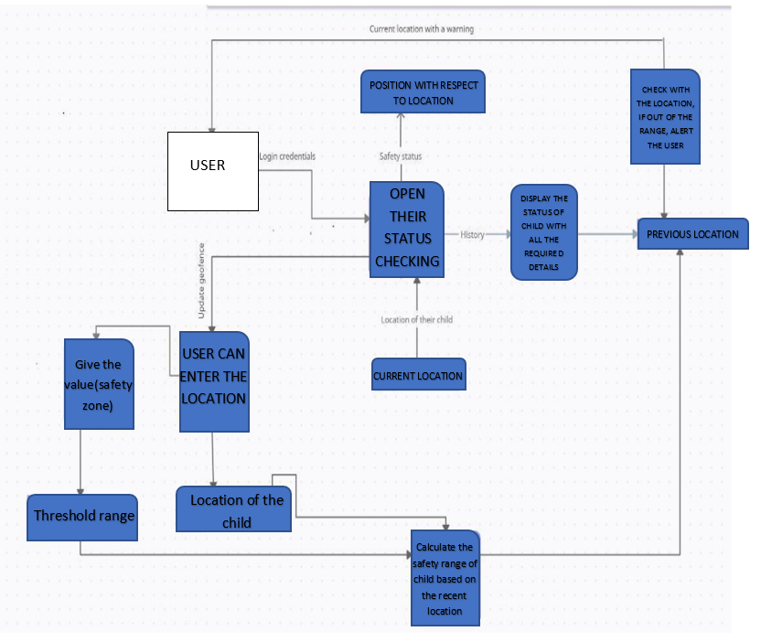

**TEAM ID: PNT2022TMID37952**

**TEAM BATCH NO: B7-1A3E**

**TEAM MENTOR: R. PADMAVATHY**

**TEAM LEADER: S. MADHUVANTHHI**

**TEAM MEMBERS:P. GLANY ROSE**

**V. POOJA**

**R. SANGETHAA**

**TEAM SIZE: 4**